SHUO LI
CS669
02/26/2018

For the last iteration you started on your term project by providing your initial list of structural business rules. This is a solid start! You have since received feedback from your facilitator, learned from more material in the course, and had some additional time to think over the term project. While this is still fresh in your mind, make any enhancements and corrections to your business rules. Then provide a conceptual entity-relationship diagram (ERD) that reflects the business rules. Recall that a conceptual ERD is independent of the relational model, and therefore does not contain primary and foreign key constraints.

Make sure that all business rules are represented in the ERD, and that all entities and relationships present in the ERD are described by the business rules.

This work is summarized in the two steps below.

- Make any enhancements and corrections to your business rules you submitted last week, and provide the updated list below.

NEW PRODUCT USE CASE

Entities: seller, product, product category;

- A seller must sell one or more products; A product must be sold by one or more sellers.
- A product category must contain one or more products; A product must be contained one and only one product category.
- A seller can build zero or many product; A product must be built by one and only one seller.

PRODUCT DELIVERY USE CASE

Entities: seller, product, warehouse;

- A seller must ship one or more products; A product can be shipped by one or more sellers.
- A warehouse must contain one or more products; A product must be contained in one or more warehouse.

NEW CUSTOMER ACCOUNT USE CASE

Entities: customer, account;

- A customer can own one or more accounts; A account must be owned by one and only one customer.

PRODUCT PURCHASE USE CASE

Entities: customer, purchase order, product, shipping speed.

- A customer can make one or more purchase order; A purchase order is made by one and only one customer.
- A purchase order can contain one or more product; A product can be contained by one or more purchase order.
- A purchase order must choose one and only one shipping speed. A shipping speed must be chosen by one or many purchase order.

PRODUCT SHIPMENT USE CASE

Entities: customer, delivery, purchase order, account

- A customer can have one or more deliveries; A delivery can be had by one and only one customer.
- A purchase order must have one or more deliveries; A deliveries can be had by one and only one purchase order.
- A account must relate to zero or many deliveries; A delivery must is related to one and only one account.

2. Create a conceptual ERD that reflects the business rules and provide it below.

This Term Project iteration is not a final submission of what you develop. You have the opportunity to make modifications before the final Term Project submission at the end of the course.
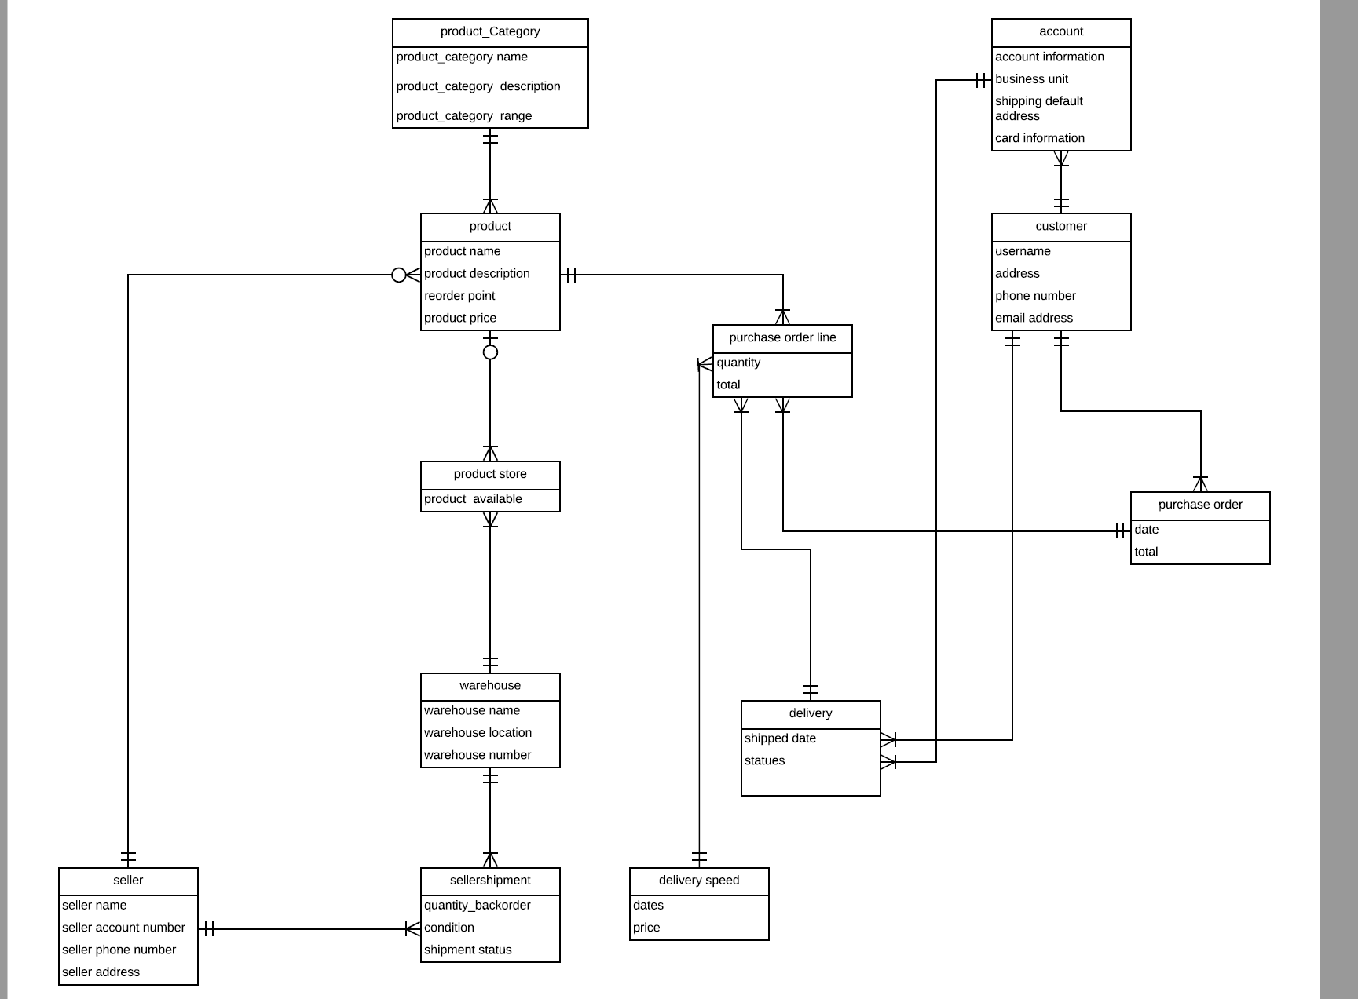

Use the Ask the Facilitators Discussion Forum if you have any questions regarding the how to approach this assignment.

Save your assignment as lastnameFirstname_iteration3.doc and submit it in the Assignments section of the course.

For help uploading files please refer to the Technical Support page in the syllabus.

